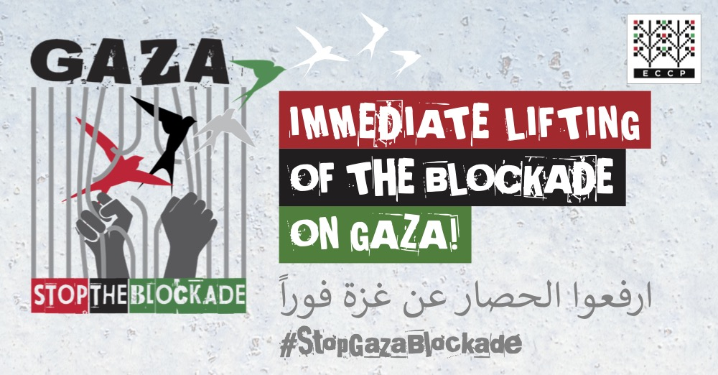

STOP GAZA BLOCKADE CAMPAIGN
March 30 Social Media action text examples

Recommended #

#LandDay #GreatReturnMarch #StopGazaBlockade #StopEthnicCleansing #StopWarCrimes #StopIsraeliApartheid #HumanRights. #UnitedWithPalestine. #EndIsraeliImpunity

Recommended @

@UN Member States @EU_Commission @IntnCrimCourt @UN_HRC @vonderleyen. @JosepBorrrellF
also tag your European and national representative.

Texts for Facebook/Twitter

Theme: Right to land and right of return

Today #Palestine commemorates #LandDay and #GreatReturnMarch. Palestianians were driven out of their ancestral land by force and by land expropriation. To all @UN Member States, support Palestinian right to their land, right of return and inalienable right to self-determination. When will you stand #UnitedWithPalestine?

46 years ago #Israeli government declared to expropriate a large swath of Palestinian Land. From the West Bank, Jerusalem, Al-Naqab to Gaza Palestinian people resisted. This is celebrated as #LandDay. Land theft and ethnic cleansing continue today. Support a long way to freedom and justice. #StopEthnicCleansing #StopGazaBlockade #StopIsraeliApartheid

55 years ago #Israel occupied the Palestinian land. 46 years ago #Israel stole the land and the first Palestian protest was met with violence. This still continues today from the West Bank, Jerusalem, Al-Naqab to Gaza. Support Palestinian struggle for justice. #StopEthnicCleansing #StopGazaBlockade #StopIsraeliApartheid

74 years of ethnic cleansing and dispossession, 55 Years of occupation, 46 years of land theft, 15 years of siege. Where is the international community? Where is the UN? Where is political will to implement international law? #StopEthnicCleansing #StopGazaBlockade #StopIsraeliApartheid

About 70% of Gaza’s population are refugees. They were driven out of their homes elsewhere in the historic Palestine. Right of return is enshrined in international law and is universally applicable to all refugees including Palestinians. But Israel denies it. On this #LandDay let Gaza live.

Theme: War crimes and impunity

2018 #LandDay during the #GreatReturnMarch Israeli army opened fire at unarmed civilians including women, children, journalists and medics. 260 dead and 27,094 injured. This is a war crime. Support the investigation @IntnCrimCourt
#StopWarCrimes from Gaza to Ukraine. #HumanRights first and #RuleOfLaw first everywhere. #StopGazaBlockade #StopIsraeliApartheid

Four years ago #GreatReturnMarch Palestinians peacefully demanded their right to freedom and their right to return to their homes from where they were expelled. The command “shoot to kill” against unarmed civilians caused an astounding number of death and injuries. Journalists and medics at work are also targeted. This is a war crime. To date nobody was held accountable. Justice is still in waiting #EndIsraeliImpunity

UNRWA Commissioner-General Pierre Krähenbühl’s remark on #GreatReturnMarch “This is a situation completely underestimated by the world. More people were injured in about 10 days of mostly peaceful demonstrations than during the 50 days of an all-out war in 2014. This should have generated far more robust reactions.” Where is international community? Where is justice?

260 dead and 27,094 injured during a year of mostly peaceful protest during the #GreatReturnMarch. Israelí soldiers in full combat gears shot unarmed civilians. To date nobody was held accountable. #EndIsraeliImpunity

Gaza was devastated by 4 military attacks and a massacre during the #GreatReturnMarch in 15 years. No recovery because of the blockade. No electricity, no clean water, no livelihood. It is a man-made disaster. It is inhuman. It is intolerable. Gaza can wait no longer. We demand immediate and unconditional lifting of the Gaza Blockade. #StopGazaBlockade #StopIsraeliApartheid #FreeGaza

